Reviving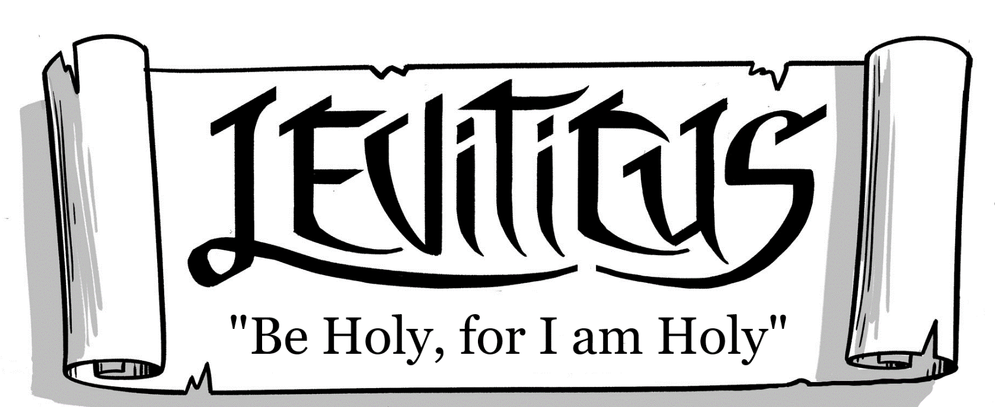
(Outline, Study Guides, Discussion Questions)

Wednesday Night Bible Study
(Quarter 4, 2020)
McRaven Road Church of Christ

How to Use This Material
This class material is intended, designed, and written to provide each student in this class the greatest amount of exposure and benefit from the Book of Leviticus. To that end, there is no “lesson text” to be read and compared with other more traditional “lesson books” there are very few questions to be answered. This can leave students wondering exactly what they should do in preparation for an upcoming Bible study. This section is written to give guidance as to how each reading should be completed prior to gathering with your fellow saints to study together.
The purpose of a Bible study class is not to “sit and get”, or to soak up as much knowledge as possible during the class session. Our classes are to be for the mutual edification (Eph. 4.16) of one another, as well as engaging in a joint search for the truth (Ephesians 4.12-13). Paul writes in Romans 15 that he was satisfied with the Roman brethren, in part, because they were “able to instruct one another” (v.14). This demands that we as students prepare ourselves beforehand to share what we have discovered about God’s word.
Students that have taken the time and energy to “fill up” on the good things in God’s word are then prepared to share those things with the rest of the class.
Doing this will result in an uplifting, encouraging, and educational Bible study!
What should I do in preparation to meet and discuss Leviticus?
1. Begin with the text itself, and not a commentary.
Begin by carefully reading the text 2-3 times.
- Find a Bible you don’t mind marking in and use colored pencils or pens to highlight key points in the text and make notes in the margins around the text.
If you are not studying the text with a pencil, you are reading, not studying!
- Don’t think God’s word is easily understood with 5-10 minutes of effort. Put in the Time!
- Your main question during this period is “What do I find interesting?”
2. Circle words, phrases, verses, or sections you do not understand.
- If you think you have a complete understanding of everything in the text in a short amount of time, then you may not have studied very carefully. Go back and look again and again!
3. Write down everything in the text you find interesting.
- The last thing to do is to focus and search the text for the “golden nuggets”.
- Record anything you find of interest, it could be useful to another member of the class!
4. Record your thoughts in each area of emphasis.
- Before answering the discussion questions, ask yourself the questions on the front of each lesson sheet, and record your thoughts in the areas provided:
- Observation: What did you see in the text?
- Interpretation: What did this section of Leviticus mean to the original hearers?
- Every third lesson we review the previous two sections through the following lenses:
- How does this unit point forward to Jesus?
- What applications should Christians make from this unit?
- What connections do we find in the New Testament from this unit?
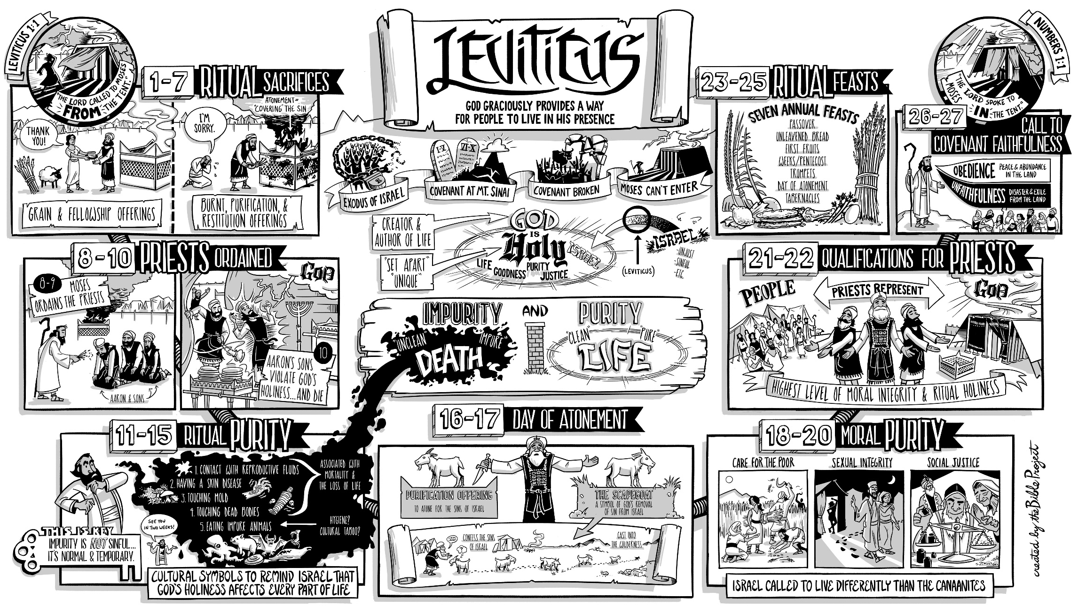

Outline of the Book of Leviticus
Major Divisions of Leviticus
Ch. 1-7:  Worship (Sacrifices) | Ch. 8-10:  The Priesthood | Ch. 11-15:  Ritual  Purity | Ch. 16:  Day of Atonement | Ch. 17-20:  Moral  Purity | Ch. 21-22:  Priestly  Standards | Ch. 23-17  Worship  (Feasts, etc.)

- Leviticus 1-7: Worship and Sacrifices
  - 1.1-17: Burnt Offerings
  - 2.1-15: Grain Offerings
  - 3.1-17: Peace Offerings
  - 4.1-5.13: Sin Offerings
  - 5.14-6.7: Guilt Offerings
  - 6.8-7.38: Priestly Regulations reg. Sacrifice
- Leviticus 8-10: The Priesthood
  - 8.1-36: Moses consecrates Aaron and Sons
  - 9.1-24: The glory of the LORD appears to Aaron
  - 10.1-20: Nadab and Abihu violate God’s holiness
- Leviticus 11-15: Ritual Purity
  - 11.1-46: Clean and Unclean Animals
  - 12:1-8: Post-partum Purification from Uncleanness
  - 13.1-59: Leprosy and Uncleanness
  - 14.1-32: Cleansing of Leprosy
  - 14.33-56: Cleansing of Leprous Houses
  - 15.1-33: Bodily Discharges and Cleanness
- Leviticus 16: The Day of Atonement
- Leviticus 17-20: Moral Purity
  - 17.1-9: The Proper Place for Sacrifice
  - 17.10-16: Prohibition Against Eating Blood
  - 18.1-30: Unclean Sexual Relationships
  - 19.1-36: “I am the LORD…you shall love your neighbor as yourself”
  - 20.1-27: Moral Uncleanness Punished by Death
- Leviticus 21-22: A Higher Priestly Standard
  - 21.1-22.16: (Topics range from prohibitions against touching dead bodies, marriage restrictions, blemishes and physical handicaps, avoiding and resolving ritual uncleanness, etc.)
  - 22.17-30: Acceptable, blemish-free offerings
  - 22.31-32: Summary
    - “You shall not profane my holy name, that I may be sanctified among the people of Israel. I am the LORD who sanctifies you.” (22.32)
- Leviticus 23-27: Worship (continued)
  - 23.1-44: The Feasts
    - V. 1-2: Summary
    - V. 3: Sabbath
    - V.4-8: Passover
    - V.9-14: Firstfruits
    - V.15-22: Weeks
    - V.23-25: Trumpets
    - V.26-32: Day of Atonement
    - V. 33-36: Booths
    - V.37-44: Additional Details
  - 24.1-4: Providing Oil for Tabernacle Lamp
  - 24.5-9: Providing the Tabernacle Bread
  - 24.10-23: Respect for the LORD’s Name
  - 25.1-7: The Sabbath Year
  - 25.8-34: The Year of Jubilee (the 7th Sabbath Year)
    - V.8-17: “proclaim liberty…return to his property…return to his clan”
    - V.18-22: God will provide for Israel during the Sabbath years
    - V.23-34: Rules regarding redemption of land
  - 25.35-46: Kindness Towards Poor Brethren
  - 25.47-55: Redemption of Poor Brethren
  - 26.1-13: Blessings for Obedience
  - 26.14-39: Punishment for Disobedience
  - 26.40-46: God Will Keep His Covenant
    - “I will not spurn them, neither will I abhor them so as to destroy them utterly and break my covenant with them, for I am the LORD their God.” (v.44)
  - 27.1-34: Laws Concerning Vows

BEFORE ANSWERING ANY QUESTIONS: read this section 1-2 times first!
(Leviticus 1-7)
Summary: what is this section of Leviticus about?
(If there is a “summary passage” in this section, write down the reference also)

Observation: What did you see in the text?
(note structure, references, patterns, repetition, key ideas, anything that stands out to you)
Interpretation: What did this section of Leviticus mean to the original hearers?
Observation and Interpretation Discussion Questions:
(please refrain from answering these until you have studied the text and answered the previous questions)
1. Which three groups does God address in this section of Leviticus? (Hint: 1.2; 5.14; 6.8-9)

2. What are the five offerings given in this section, and what are their purposes?

3. What spiritual process is repeatedly described in 4.1-6.7? (Hints are below)
_______________ → _________________ → ____________________ → ___________________
(4.22-26) (4.27-31) (5.11-13)

4. What are the main concepts of the “priestly section” (Lev. 6.8-7-36)?

5. What was the difference between the sin and the guilt offerings?

BEFORE ANSWERING ANY QUESTIONS: read this section 1-2 times first!
(Leviticus 23-27)
Summary: what is this section of Leviticus about?
(If there is a “summary passage” in this section, write down the reference also)

Observation: What did you see in the text?
(note structure, references, patterns, repetition, key ideas, anything that stands out to you)
Interpretation: What did this section of Leviticus mean to the original hearers?
Observation and Interpretation Discussion Questions:
(please refrain from answering these until you have studied the text and answered the previous questions)
1a & 1b. What are the “holy convocations” (ESV) in Lev. 23, and what do they all have in common?

2. Why was blasphemy of the LORD’s name a capital offense? (Ex. 6.2-8; Ex. 20.7; Ex. 33.19; Ex. 34.5-7)

3. What effects would the economic policies of Lev. 25 have on Israel as a nation?
(Hint: Who does God always remember and protect? (Ex. 21.1-11; Lev. 25.35-55?)

4. Describe the “plot” of Lev. 26.

5. How was worship of “the LORD” (Yahweh) built into the everyday lives of Israelites.

6a & 6b. Why would this entire book end with laws pertaining to vows? What is the point of ch. 27?

The title of this study is “Reviving Leviticus”, and the ultimate goal of this study is to see that the book of Leviticus is relevant to our lives as Christians. One of the great temptations of Leviticus (which is shared by many other O.T. books) is to dismiss it as part of the “Old Covenant” and therefore not helpful or meaningful to Christians today. This could not be farther from the truth. This great book is centered on Holiness, and the four key themes of holiness that Leviticus explores (Worship, the Priesthood, Purity, and Atonement) are integral to the Christian way of life. Leviticus gives us the framework and background to understand each of these concepts and apply them in the way the New Testament authors intended.
The third lesson of each three-week “unit” of our study will review the texts from the previous two weeks through the lens of three key questions:
- How does each unit point forward to Jesus?
- What applications should Christians make from this unit?
- What connections do we find in the New Testament from this section?
These guiding questions will enable us to make the proper APPLICATION of these texts as well as enable us to effectively COMMUNICATE those principles to others as we discuss the Bible.
BUT FIRST: READ IT ONE MORE TIME: (Leviticus 1-7, 23-27)
#1: How does the “worship” section of Leviticus (1-7, 23-27) point forward to Jesus?
(What do you see in these sections that reminds you of Jesus, His work, His sacrifice, etc.?)

#2: What applications in regard to worship should Christians make from this unit?
(If possible, provide support from N.T. passages for each application)

#3: What connections do you see in the New Testament to these sections of Leviticus?

BEFORE ANSWERING ANY QUESTIONS: read this section 1-2 times first!
(Leviticus 8-10)
Summary: what is this section of Leviticus about?
(If there is a “summary passage” in this section, write down the reference also)

Observation: What did you see in the text?
(note structure, references, patterns, repetition, key ideas, anything that stands out to you)
Interpretation: What did this section of Leviticus mean to the original hearers?
Observation and Interpretation Discussion Questions:
(please refrain from answering until you have studied the text and answered the previous questions)
1a & 1b. What sacrifices are used in the priestly ordination process, and what was their purposes?

2. What is the sequence of events in the ordination process (ch. 8)?

3. How does the “leading role” in this text shift between ch. 8 and 9?

4. How does Nadab and Abihu’s “unauthorized fire” (10.1, ESV) starkly contrast with ch. 8-9?

5. Why wouldn’t Aaron and sons eat of the sin offering, as they were required to do (Lev. 6.24-29)?

Bonus: During the ordination offering (8.22-29), why was the blood applied to the right ear/thumb/big toe of Aaron & sons?

BEFORE ANSWERING ANY QUESTIONS: read this section 1-2 times first!
(Leviticus 21-22)
Summary: what is this section of Leviticus about?
(If there is a “summary passage” in this section, write down the reference also)

Observation: What did you see in the text?
(note structure, references, patterns, repetition, key ideas, anything that stands out to you)
Interpretation: What did this section of Leviticus mean to the original hearers?
Observation and Interpretation Discussion Questions:
(please refrain from answering until you have studied the text and answered the previous questions)
1. According to the text, why were priests subject to far stricter rules than the average Israelite?

2. What similarities do you see between the requirements for the priests and those for the sacrifices?

3. How does this text emphasize God’s kindness and consideration alongside His holiness?

4. Was it sinful for a priest (or any Israelite, for that matter) to become unclean?

5. What was the penalty for violating God’s holiness in any way?

6. Describe if/how cleanness and uncleanness are transmitted.

Leviticus 8-10 and 21-22 highlight the establishment of the Levitical priesthood and the standards under which they would live and serve as holy priests of God. The concepts of priesthood and priestly holiness are found throughout the New Testament, in particular in reference to the relationship of Jesus to us, and to God.
Early in the book of Hebrews the writer calls the hearer to “Consider Jesus” (3.1) and describes Him as “the apostle and high priest of our confession”. He is the High Priest who is able to sympathize with our weakness (4.15), and was an example of the holy living that we are called to practice as Christians: “For it was indeed fitting that we should have such a high priest, holy, innocent, unstained, separated from sinners, and exalted above the heavens.” (Heb. 7.26). It was Jesus who would officiate the greatest sacrifice on behalf of mankind, entering the holy place of Heaven itself and offering Himself for our sakes, “securing an eternal redemption” (Heb. 9.12).
The Christians’ relationship to Jesus and to God is also described using the language of the Levitical priesthood. Consider Peter’s two-fold description of Christians in 1 Peter 2 as priests: “you yourselves are like living stones are being built up as a spiritual house, a holy priesthood, to offer spiritual sacrifices acceptable to God through Christ Jesus…But you are a chosen race, a holy priesthood, a holy nation…” (v.5, 9). As priests of God serving under Jesus, we are called to accept God’s discipline in order “that we may share His holiness” (Heb. 12.10). In v.14 of the same chapter we are instructed to “strive for peace with everyone, and for the holiness without which no one will see the Lord” (v.14). The specific standards for priestly holiness differ between the Old and New Covenants, but priests under both systems are motivated to be holy for the same reason: “Be holy, for I am holy” (1 Pet. 1.16).
As before, we will review the texts from the previous two weeks through the lens of three key questions:
- How does this unit point forward to Jesus?
- What applications should Christians make from this unit?
- What connections do we find in the New Testament from this section?
BUT FIRST: READ IT ONE MORE TIME: (Leviticus 8-10, 21-22)
#1: How do the “priesthood” sections of Leviticus (ch. 8-10, 21-22) point forward to Jesus?
(What do you see in these sections that reminds you of Jesus, His work, His sacrifice, etc.?)
#2: What applications in regard to the priesthood should Christians make from this unit?
(If possible, provide support from N.T. passages for each application)

#3: What other N.T. connections do you see in these sections of Leviticus?

BEFORE ANSWERING ANY QUESTIONS: read this section 1-2 times first!
(Leviticus 11-15)
Summary: what is this section of Leviticus about?
(If there is a “summary passage” in this section, write down the reference also)

Observation: What did you see in the text?
(note structure, references, patterns, repetition, key ideas, anything that stands out to you)
Interpretation: What did this section of Leviticus mean to the original hearers?
Observation and Interpretation Discussion Questions:
(please refrain from answering until you have studied the text and answered the previous questions)
1. Was becoming unclean sinful? (Provide evidence/reasons/passages to support your answer)

2a & b. What common characteristic did the clean/unclean animals generally share?

3. What common element in all of these situations caused uncleanness to spread?

4. Why do some situations require atonement by sacrifice to become clean (childbirth, leprosy, etc.) while others simply require washing and time (touching unclean animals, bodily fluids, etc.)?

5. How does Lev. 15.31 help us understand the point of the “ritual purity” laws?

BEFORE ANSWERING ANY QUESTIONS: read this section 1-2 times first!
(Leviticus 17-20)
Summary: what is this section of Leviticus about?
(If there is a “summary passage” in this section, write down the reference also)

Observation: What did you see in the text?
(note structure, references, patterns, repetition, key ideas, anything that stands out to you)
Interpretation: What did this section of Leviticus mean to the original hearers?
Observation and Interpretation Discussion Questions:
(please refrain from answering until you have studied the text and answered the previous questions)
1. How are the purity laws in ch. 17-20 different from those in 11-15?

2a & b. What was the single distinguishing characteristic between Israel and the surrounding nations, and how was this expressed in God’s commands to Israel in this section? (Also, Ex. 33.16)

3. How does God tie together the two “purity” sections of Leviticus in 20.22-26?

4. Why aren’t violations of the “moral purity” laws followed by instructions for atonement, like the “ritual purity” laws of ch. 11-15? (Hint: see Lev. 4.1, 4.13, 4.22, 4.27; as well as Num. 15.22-31)

5. How does Lev. 19.9-18a show us what it means to “love your neighbor as yourself” (19.18b)?

Leviticus 11-15 and 17-20 draw the reader closer to the eventual high point of the book, but not without first delivering a heavy dose of Purity. This is done for Israel’s own sake, since God will not allow anything that is impure/unholy/unclean to be allowed to violate His holiness: “You shall be holy to me, for I the LORD am holy and have separated you from the peoples, that you should be mine.” (Lev. 20.26). God’s own holiness was expected to permeate His people both physically and morally, and Israel would need to become holy in order for God to dwell among them.
Today the spiritual nation of Israel, the “holy nation” as Christians are described in 1 Peter 2.9, are likewise called to live lives of holiness based on God’s holiness. Peter draws on this concept found in both “purity” sections of Leviticus (11.44 and 19.2) to solidify this point:
“Therefore, preparing your minds for action, and being sober-minded, set your hope fully on the grace that will be brought to you at the revelation of Jesus Christ. As obedient children, do not be conformed to the passions of your former ignorance, but as he who called you is holy, you also be holy in all your conduct, since it is written, ‘You shall be holy, for I am holy.’”
(1 Pet. 1.13-16 ESV)
Our standards for holiness in the N.T. both differ and coincide with various aspects of the Levitical holiness laws, but the motivation and seriousness expressed are certainly shared between the two. God is still holy, and He calls on His people to exhibit physical and moral holiness.
As before, we will review the texts from the previous two weeks through the lens of three key questions:
- How does this unit point forward to Jesus?
- What applications should Christians make from this unit?
- What connections do we find in the New Testament from this section?
BUT FIRST: READ IT ONE MORE TIME: (Leviticus 11-15, 17-20)
#1: How does the “purity” sections of Leviticus (ch. 11-15, 17-20) point forward to Jesus?
(What do you see in these sections that reminds you of Jesus, His work, His sacrifice, etc.?)
#2: What applications in regard to purity should Christians make from this unit?
(If possible, provide support from N.T. passages for each application)

#3: What other N.T. connections do you see in these sections of Leviticus?

BEFORE ANSWERING ANY QUESTIONS: read this section 1-2 times first!
(Leviticus 16.1-19)
Summary: what is this section of Leviticus about?
(If there is a “summary passage” in this section, write down the reference also)

Observation: What did you see in the text?
(note structure, references, patterns, repetition, key ideas, anything that stands out to you)
Interpretation: What did this section of Leviticus mean to the original hearers?
Observation and Interpretation Discussion Questions:
(please refrain from answering until you have studied the text and answered the previous questions)
1. What connection should readers/hearers of Leviticus make between the deaths of Nadab and Abihu referenced in v.1 and the prohibition against going “behind the veil” in v.2?

2. What is ultimately required from Aaron before he can go behind the veil?

3. List all that must be atoned for during the “Day of Atonement” ceremony in Lev. 16.1-19, and the common method by which they are all atoned.

4a & b. Who or what was atoned for first? Why was this necessary?

5a & b. Who was permitted inside the grounds of the Tabernacle during the atonement ceremony? Why?

Bonus: In v.8, the two goats were both sent to personal beings: “one lot for the LORD and the other lot for Azazel” (ESV). Who would the opposing side to God, and why is it significant that the sins of Israel were borne by the goat back to “Azazel”?

BEFORE ANSWERING ANY QUESTIONS: read this section 1-2 times first!
(Leviticus 16.20-34)
Summary: what is this section of Leviticus about?
(If there is a “summary passage” in this section, write down the reference also)

Observation: What did you see in the text?
(note structure, references, patterns, repetition, key ideas, anything that stands out to you)
Interpretation: What did this section of Leviticus mean to the original hearers?
Observation and Interpretation Discussion Questions:
(please refrain from answering until you have studied the text and answered the previous questions)
1a & b. What was the point of leading the sin-laden goat into the wilderness, and why was the leader of said goat required to wash himself afterwards?

2a & b. Why wasn’t the flesh of the “Day of Atonement” sin offerings eaten (as usual), and why did he who carried them outside to be burned wash himself and his clothes?

3. Why did the High Priest have to wash himself after offering atonement?

4. Why was this day declared to be a Sabbath, and what did it mean for Israel to “afflict” themselves? (cf. Lev. 23.26-32)

5. What was demonstrated by the yearly renewal of this ceremony?

Leviticus 16 is the central focus of this great book, and the “Day of Atonement” ceremony described in ch. 16 is of utmost importance. We have noted throughout this study how Jesus is the ultimate fulfillment of the concepts described in Leviticus, and nowhere is that point more plainly revealed to us than in the process of atonement.
*NOTICE: The reading assignment highlighted below is different*
The three key questions we have asked each week in regard to Leviticus are of particular importance in this pivotal section of the book:
- How does this unit point forward to Jesus?
- What applications should Christians make from this unit?
- What connections do we find in the New Testament from this section?
Special Reading Assignment: (Leviticus 16; then Hebrews 9-10)
#1: How does the “Day of Atonement” described in Lev. 16 point forward to Jesus?
(What do you see in this section that reminds you of Jesus, His work, His sacrifice, etc.?)
#2: What applications in regard to atonement should Christians make from this unit?
(If possible, provide support from N.T. passages for each application)

#3: What other N.T. connections do you see in this chapter of Leviticus?

